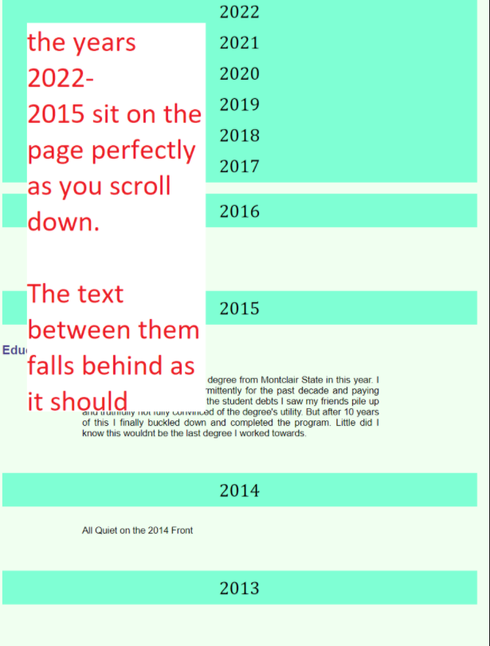

I want to fix this so the text continues to roll up –- this is where I need your help

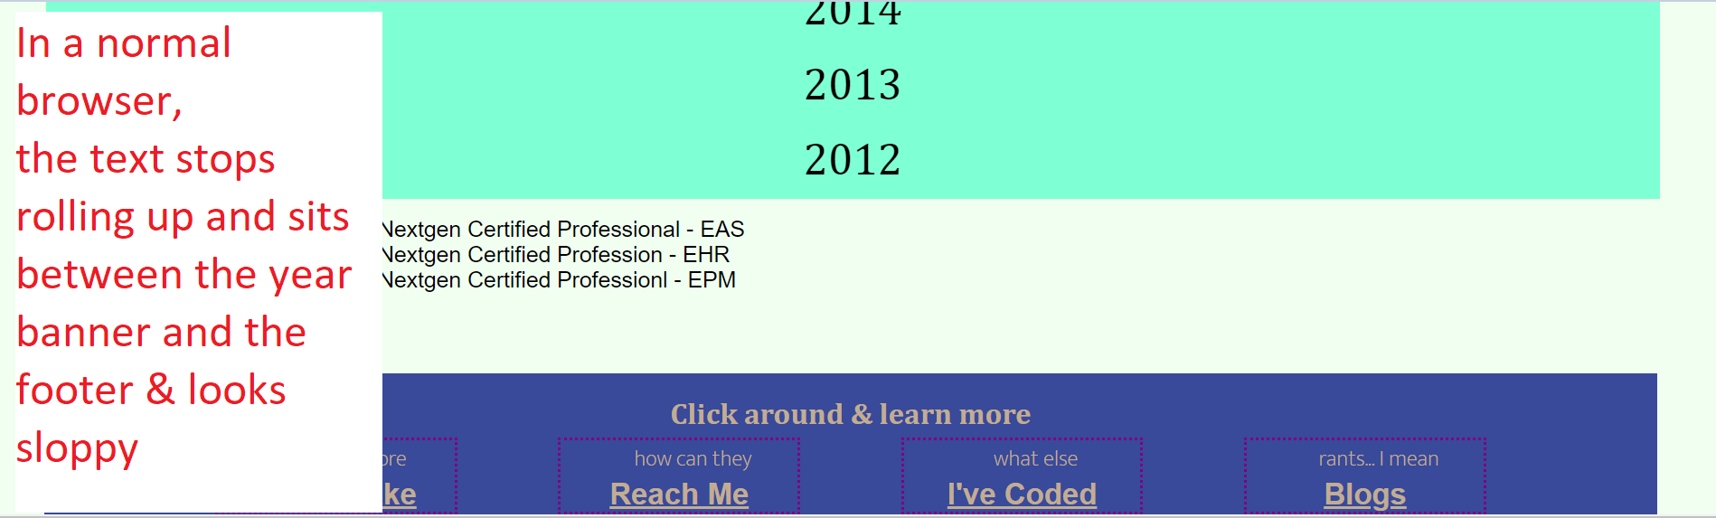

I want the banners to not over-write one another -- & this is where I need your help

